FD I/O SET UP

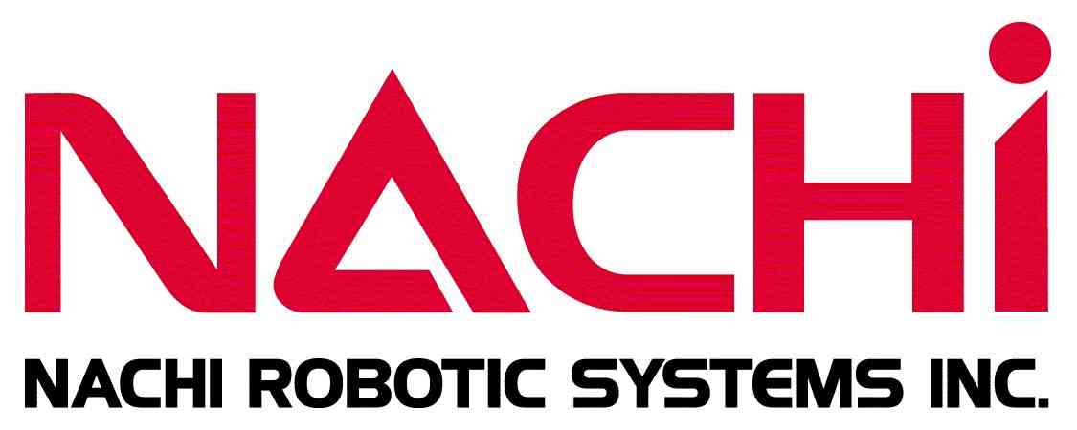

Course Length: 2 day
Course Synopsis: | This course will familiarize the students with the skills to understand setting up the I/O and Interface Panel in an FD controller and Interfacing with External Equipment. The I/O consists of Discrete, Field Bus (Device Net, Either Net) and NACHI PLC logic. To insure sufficient hands-on experience and encourage instructor / trainee discussion, Nachi recommends a maximum class size of six (6) trainees. Performance objectives will be met utilizing a combination of 50% classroom lectures and 50% hands-on lab projects, dependant upon the skill level of the students as a group.
Who Should Attend: | This course is intended for integrators, skilled tradesmen, engineering personnel and workers whose responsibilities include operation, programming, program modifications, and repair or maintenance of the FD Controller.
Prerequisites: | Trainees scheduled for this course should have completed a basic robot course or have equivalent industrial manufacturing work experience.
What You Will Learn: | - Safety Devices  - Nachi Safety Interlocks  - Online HELP Message  - Dedicated I/O  - User I/O  - Field Bus set up  - Either net set up  - PLC Ladder Logic  - Nachi Interface Panel (HMI) set up
Time: | Class time is 7:30 a.m. – 3:30 p.m.  Breaks are scheduled throughout the day and lunch will be provided at roughly 11:30 a.m.
Course Materials: | Course materials are provided by the instructor. We may change or alter course topics to best suit the classroom situation.
Locations: | The Nachi Training Center is located in Novi, Michigan. Courses can also be conducted at our customer’s facility upon request, please contact us for special pricing information.
Related Courses:  Registration: | FD Electrical Maintenance Course  Courses are scheduled in accordance to customer requests and requirements. Please visit our web site www.nachirobotics.com or call (248) 305-6545 for pricing and availability.

